DBMS RECORD OUTPUT
- Find the salary of all clerks and managers?
CREATE
create table Employee(Emp_id int Primary key,Empfname varchar(20),Emplname varchar(20),Dept varchar(20),Pjt varchar(20),Address varchar(50),DOB DATE,Gender varchar(20));

create table Empdesig(Emp_id int Primary key,Emp_position varchar(20),DateOfJoin DATE,Salary int,Foreign Key(Emp_id) REFERENCES Employee(Emp_id));

INSERT

To find the salary of all clerks and managers?
Select SUM(Salary) From Empdesig WHERE Emp_position IN ("Clerk","Manager");
OUTPUT
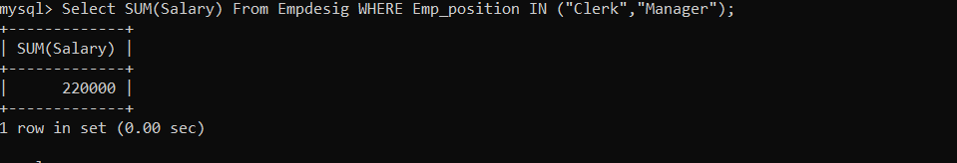

- Fetch the no of employees working in the “HR” department?
Select COUNT(DEPT) FROM Employee WHERE Dept="HR";
OUTPUT

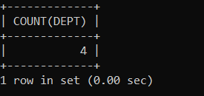

- Fetch the first four characters of emplname from the employee table?
Select SUBSTRING(Empfname,1,4)FROM Employee;
OUTPUT

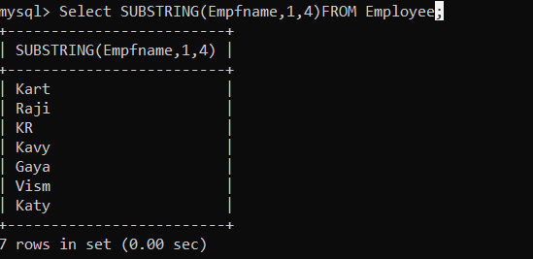

- Find all employee details whose salary is between 10000 and 40000?

SELECT * FROM Empdesig WHERE Salary BETWEEN 10000 AND 40000;

OUTPUT
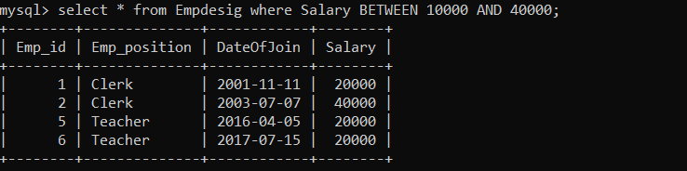

- Create a new table which consists of data and structure copied from employee table?

create table NewEmployee AS(SELECT * FROM Employee);
OUTPUT
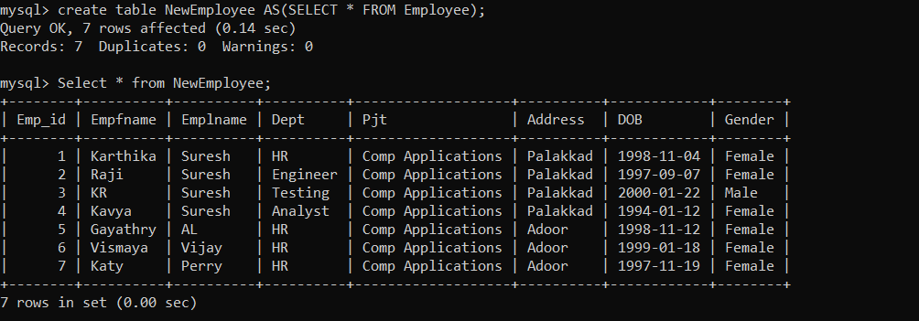

- To find details of employees whose emplname ends with ‘ A’ and contains five alphabets?

SELECT * FROM Employee WHERE Emplname LIKE "%____a";

OUTPUT
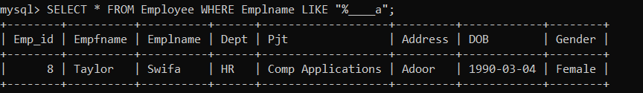

- To add email validation to your database?
Alter TABLE Employee ADD Email varchar(200);
UPDATE Employee SET Email="taylorswifa@gmail.com" WHERE Emp_id=8;
UPDATE Employee SET Email="katyperry67@gmail.com" WHERE Emp_id=7;
select * from Employee where Email LIKE "%gmail.com";

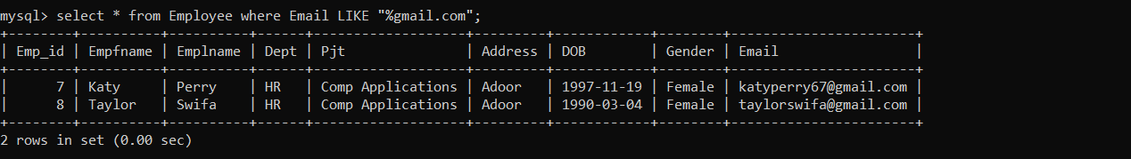
OUTPUT

- To find the second highest salary ?
SELECT Max(Salary) as SALARY FROM Empdesig WHERE Salary <(SELECT MAX(Salary) FROM Empdesig);
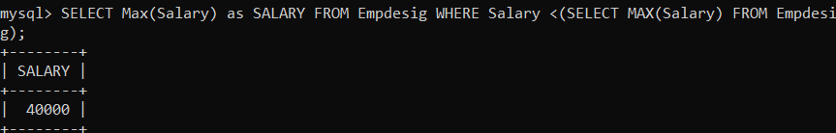

- Write a plsql program
a. to display the message ” welcome to plsql”.
b.to check whether a given character is a letter or a digit.

begin
dbms_output.put_line('WELCOME TO PL/SQL');
end;
/
OUTPUT
WELCOME TO PL/SQL

b)

